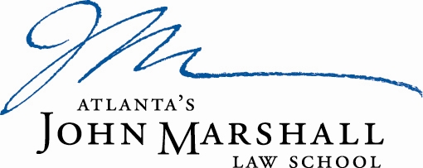

Atlanta’s John Marshall Law School is looking for a motivated and energetic individual to fill the full time position of Institutional Development and Alumni Director. The Institutional Development and Alumni Director is responsible for building lasting relationships, all activities related to identification, cultivation, solicitation, and stewardship of annual, major, and planned gifts from alumni, friends, corporations, and foundations.

The ideal candidate will have a minimum of a Bachelor’s Degree (Master’s or J.D. preferred) and three years of experience in annual giving and/or alumni relations, preferably in a law school or other post-secondary education. The candidate must have excellent organizational and effective written and oral communication skills. AJMLS is an equal opportunity employer and does not discriminate in any of its programs or activities on the basis of race, gender, sexual orientation, national or ethnic origin, marital status, age, disability, color, or religious belief. Salary will be competitive based on experience. Interested candidates may submit their letter of interest, along a current professional resume and the names of three references, to:

Ms. Erika S. Murray
Executive Assistant to the Dean
Atlanta’s John Marshall Law School
1422 W. Peachtree St. N.W.
Atlanta, Georgia 30309
emurray@johnmarshall.edu

