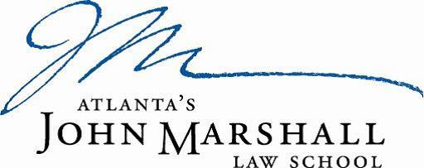

COVID-19 ACKNOWLEDGMENT
I have been advised of the symptoms related to COVID-19, including but not limited to, fever, chills, cough, shortness of breath or difficulty breathing, fatigue, muscle or body aches, headache, new loss of taste or smell, sore throat, congestion or running nose, nausea or vomiting, or diarrhea. I understand the listed symptoms are based upon current CDC guidance which may change overtime.
Should I or anyone in my household test positive for COVID-19 or develop any symptoms of the virus, I will stay home and contact my supervisor, if an employee, or an Associate Dean, if a student, to discuss any specific circumstances. I agree to inform my supervisor, if an employee, or an Associate Dean, if a student, if I test positive or show symptoms of COVID-19.
I understand that I may be required to obtain medical clearance from a physician before returning to work or school.
I understand it is my responsibility to self-monitor for any symptoms each day before reporting to work or school.
I understand it is my responsibility to adhere to the Law School’s COVID-19 protocols and procedures, including public health recommendations, intended to slow the spread of the virus.

______________________________ ______________________
Signature Date

______________________________
Print Name

