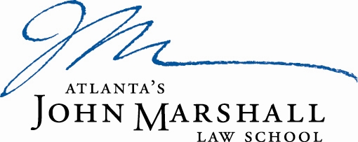

Atlanta’s John Marshall Law School is looking for a motivated individual to fill the full time position of Assistant Registrar. The Assistant Registrar will assist the Registrar with the maintenance and integrity of all student academic files in accordance with school policies and procedures and state and federal regulations pertaining to student records management.

Ideal Experience and Qualifications
Applicants must have a Bachelor’s degree, excellent academic credentials and a demonstrated commitment to working with students to improve their academic performance. Preference will be given to applicants who have a minimum of two years of administration experience in a Registrar’s office. The Assistant Registrar will be responsible for, but not limited to following:

- Researching student files for character and fitness documentation throughout the semester for students planning to take state bar examinations. Additionally, advising students about disclosure and amends their law school application in preparation for the state bar examination
- Responding electronically to character and fitness solicitation and/or written solicitations from Boards of Bar Examiners; primarily during the spring and fall responds to inquiries from Law School Community
- Processing transcripts requests daily
- Completing and submitting student loan deferments not supported by the National Student Clearinghouse
- Printing and distributing faculty class and grade rosters
- Assisting with registration and grading
- Preparing mid-term and final exams for and assisting proctors, assisting with final exam administration, and administering accommodation exams
- Monitoring and preparing report of student transferring to other institutions
- Providing verification of enrollment and JD degrees
- Submits online requests for CALI award recipients at the end of every semester and distribute awards to students
- Updating and maintaining student records according to privacy policies and procedures (FERPA)
- Ensuring that all student academic files are in compliance with ABA and Federal guidelines.
- Providing student advisement for Juris Doctor requirements
- Processing student name and address changes
- Ordering diplomas for graduating students
- Responding to all other solicitations on behalf of students (jury duty, confirmation of attendance, scholarships applications, etc.)

Atlanta's John Marshall Law School values a diverse workforce and inclusive culture. We are committed to equal opportunity without regard to race, color, religion, gender, sexual orientation, gender identity or expression, age, national origin, marital status, citizenship, disability, and veteran status. We encourage applications from all qualified individuals. Applicants with disabilities who may need accommodations in the application process to contact Ms. Davenporte.

All interested candidates may submit their letter of interest, along a current professional resume and the names of three references, to:

Cynthia Davenporte
Director of Human Resources
Atlanta’s John Marshall Law School
245 Peachtree Center Ave., NE, Suite 1900
Atlanta, Georgia 30303
cdavenporte@johnmarshall.edu

