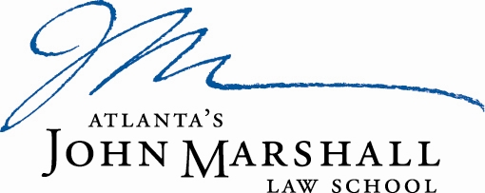

Atlanta’s John Marshall Law School is looking for a motivated individual to fill the full time position of Chief Development Officer. The Chief Development Officer is responsible for planning and implementing strategies to secure donors and contributions in support of the organization, providing oversight of the fund development program, monitoring development activities, and addressing issues that may hamper growth and success. Responsibilities will also include providing services to build lasting relationships with law alumni and administering the solicitation and stewardship of annual gifts to the Law School. This includes program development, events, reunions, communications and solicitation efforts that will engage law alumni.

The ideal candidate will have a minimum of a Bachelor’s Degree in Business Administration (Master’s or J.D. preferred), five years of experience in managing projects, fundraising, annual giving and/or alumni relations, preferably in a law school or other post-secondary education, knowledge/experience re the Greater Atlanta and regional philanthropic community. The candidate must have excellent interpersonal, decision-making, leadership skills, and also strong verbal and written communications skills. AJMLS is an equal opportunity employer and does not discriminate in any of its programs or activities on the basis of race, gender, sexual orientation, national or ethnic origin, marital status, age, disability, color, or religious belief. Salary will be competitive based on experience. Interested candidates may submit their letter of interest, along a current professional resume and the names of three references, to:

Cynthia Davenporte
Director of Human Resources
Atlanta’s John Marshall Law School
1422 W. Peachtree St. N.W.
Atlanta, Georgia 30309
cdavenporte@johnmarshall.edu

