Atlanta’s John Marshall Law School

19
12Twenty – The Advocate
Student Handbook
Office of Career Development

Contents
For Students… 2
How to access your student account 2
Pro Bono 5
Overall Process 5
Create your pro bono record 5
Add hours to your pro bono record 5
Community Service 6
Overall Process 6
Create your community service record 6
Add hours to your community service record 6
Jobs 7
How to apply for a job 7
Application Materials 7
Help 7
OCI 7
Documents 8
How to add your resume, cover letter, and more 8
Appointments 8
Events 8
Tasks 8
Experiential Learning 9
Overall Process 9
Externship Registration (Secured Placement Application) 9
Externship Registration (Secured Placement Application) Approval Process 13
Add hours to your externship 13
Evaluations (Student, Employer) 14
Completion 14
Tips 15
Troubleshoot 15

For Students…

How to access your student account
To access your new 12Twenty account, please click the link below:
https://law-ajmls.12twenty.com/SignUp/Student
Once the webpage loads, you will need to complete the following:
- Enter your school email address (@johnmarshall.edu or @savannahlawschool.org)
- Create a password
- Review and agree to AJMLS’s Student Professionalism Agreement
- Review and agree to 12Twenty Terms of Service and Privacy Policy
When done, click Student/Alumni Sign Up
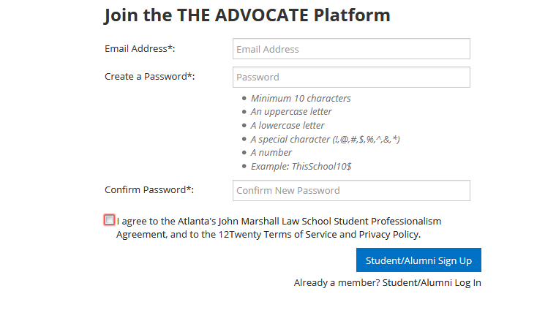

When you click Student/Alumni Sign Up, you will be taken to the student information page. At a minimum, please fill out/complete the required fields (indicated by an *). Once done, click Continue.
**Telephone and address must be current**
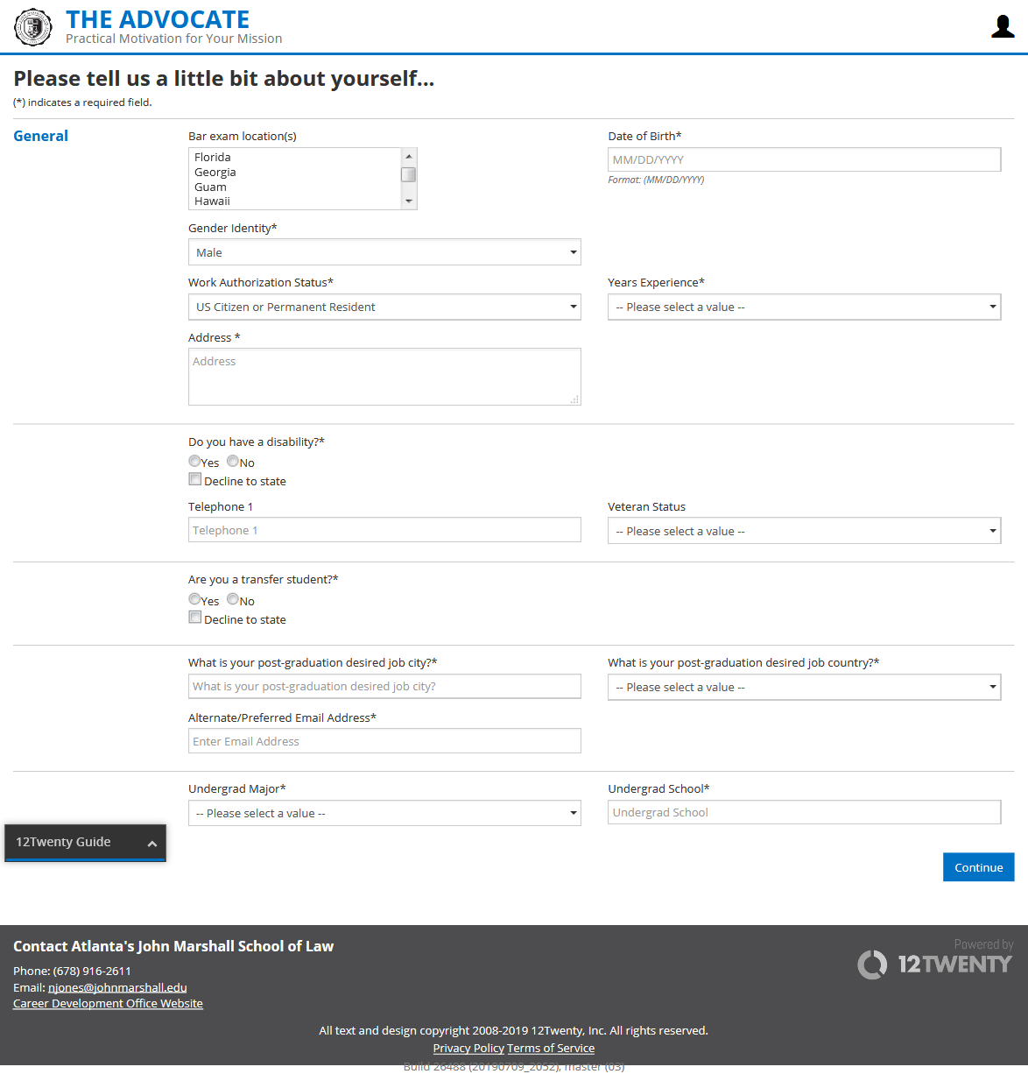

After clicking Continue, you will be taken to your profile page. Please spend some time familiarizing yourself with the system. If you need help, there is a built-in help tool (12Twenty Guide) located at the bottom left that will help you with basic functions.
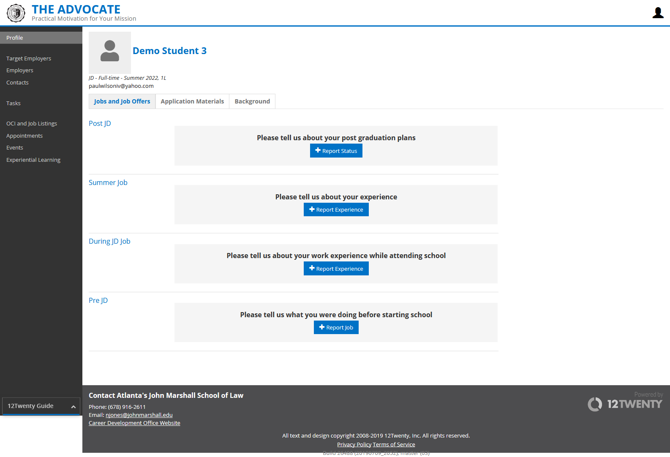

Pro Bono

Overall Process
- Create and submit pro bono experience
- Add hours
- Final Approval

Create your pro bono record
- Access your student account
- Click Experiential Learning in the menu on the left
- Click New Experience at the top right
- Under the Basics section, select Experiential Learning Type, and then click Pro Bono
- Complete required information
- When all information has been entered, click Save. This action will take you to a preview of your pro bono experience before final submission
- If you need to make edits to your record before submission, select Action at the top right and click Edit
- If you do not need to make edits to your pro bono experience, click Submit at the top right
- Once you have submitted your pro bono experience, your status will change to In Progress at the top of the page
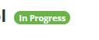
- Now that your status is In Progress, you may enter your hours into the hour log
- When you have completed your pro bono experience and all hours are entered, click Submit for Approval at the top right and your status will change to Complete

Add hours to your pro bono record
- Once you have created your pro bono experience, you can add hours by clicking on the Hour Log tab at the top of the page
- Under the Hour Log tab, click Add Hours at the top right and a new window will appear called Create New Hour Log Entry
- Under Create New Hour Log Entry, enter the date, hours, and the description of your service
- Once complete, click Save and the hours will be added to your pro bono experience
- *Hours can only be entered on a daily basis. If you are recording hours weekly, put the date of the hours completed and then note the week (e.g. 8/26-8/30/19) in the description box along with your work performed.

Community Service

Overall Process
- Create and submit community service experience
- Add hours
- Final Approval

Create your community service record
- Access your student account
- Click Experiential Learning in the menu on the left
- Click New Experience at the top right
- Under the Basics section, select Experiential Learning Type, and then click Community Service
- Complete required information
- When all information has been entered, click Save. This action will take you to a preview of your community service experience before final submission
- If you need to make edits to your record before submission, select Action at the top right and click Edit
- If you do not need to make edits to your community service experience, click Submit at the top right
- Once you click Submit, your status will change to In Progress
- Now that your status is In Progress, you may enter your hours into the hour log
- When you have completed your community service experience and all hours are entered, click Submit for Approval at the top right. This will send your community service experience record to the Assistant Dean of Student Affairs, Hope Jamison, for final approval.
- If your community service experience is approved, your status will change to Complete. However, if additional information is required, you will receive an email detailing next steps from Dean Jamison.

Add hours to your community service record
- Once you have created your community service experience, you can add hours by clicking on the Hour Log tab at the top of the page
- Under the Hour Log tab, click Add Hours at the top right and a new window will appear called Create New Hour Log Entry
- Under Create New Hour Log Entry, enter the date, hours, and the description of your service
- Once complete, click Save and the hours will be added to your community service experience
- *Hours can only be entered on a daily basis. If you are recording hours weekly, put the date of the hours completed and then note the week (e.g. 8/26-8/30/19) in the description box along with your work performed.

Jobs

How to apply for a job
After logging in to your student account:
- Click OCI and Job Listings on the left side of your screen
- Click on the job you would like to apply to
- Click on the blue Apply button at the top right of the screen
- Follow the prompts to complete your application.
  - If you are applying through email, a prompt will include the email address to which you will apply and the application documents to be included.
  - If you are applying for the position directly through 12Twenty, you will need to upload the application materials to your profile for approval.

Application Materials
To upload into application materials, navigate to the “Profile” tab in the menu on the left side of the screen, select the “Application Materials” tab and upload the documents you need to apply for the position. Once approved, you can then select the documents with which you will apply and then submit your application. Follow the prompts for applications through external websites or through a physical mailing address.

Help
Use the help tool (12Twenty Guide) located in the menu on the left at the bottom for guidance if needed.

OCI
Contact the Career Development Office for further details

Documents

How to add your resume, cover letter, and more
- Log into your student account
- On your profile page, select the Application Materials tab. Once the tab has loaded, you can select the desired document you wish to upload
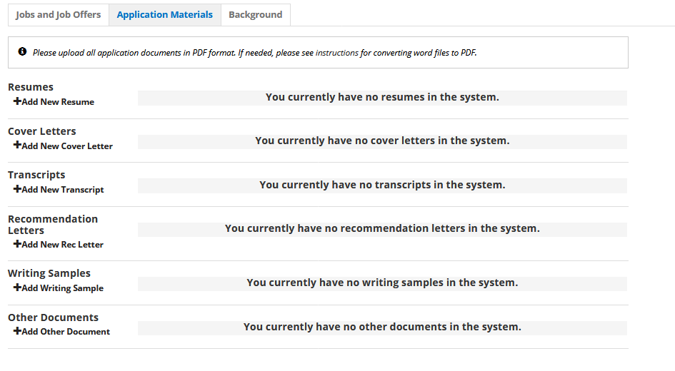

Appointments
Contact the Career Development Office for further details

Events
Contact the Career Development Office for further details

Tasks
Contact the Career Development Office for further details

Experiential Learning

Overall Process
- Create and submit new student experiential learning experience (Externship Registration – Secured Placement Application)
- Approval process (1st-Office of Experiential Learning, 2nd-Externship Supervisor, 3rd-Registrar)
- Add hours
- Evaluations
  - Midterm (Student Self Evaluation, Employer Midterm Evaluation)
  - Midterm Conference (1st time externs only)
  - End of Semester (Student Program Evaluation, Employer Final Evaluation)
- Completion

Externship Registration (Secured Placement Application)

From your student profile page, select Experiential Learning in the menu to the left.

Then click New Experience at the top right

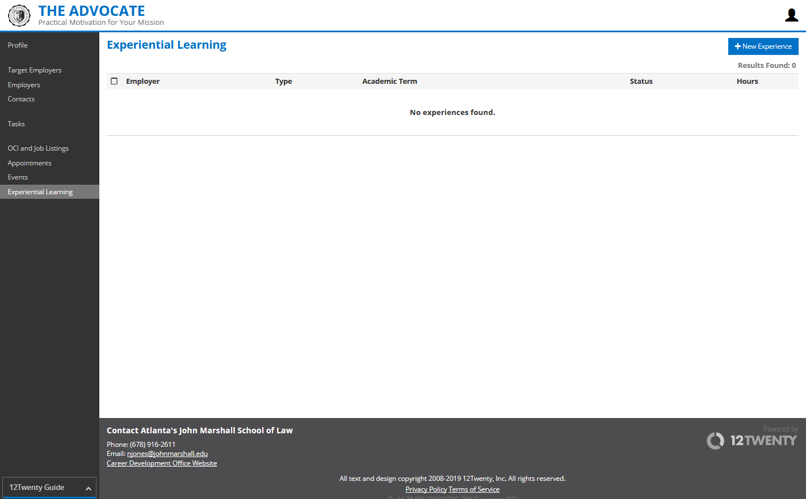

Once you click New Experience, you will be taken to Create New Experience. Please make sure you read the notice at the top of the page. When done, fill out/complete the remainder of the registration.

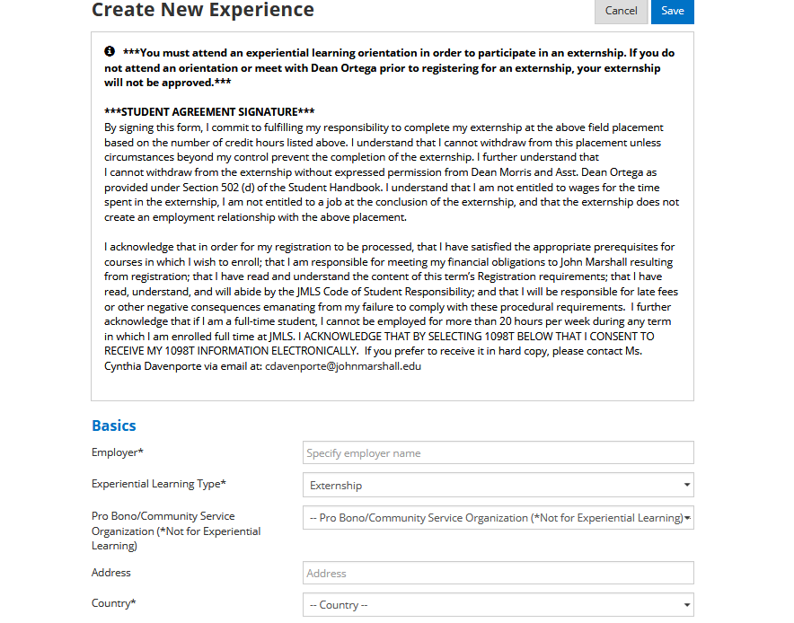

Under the Basics section, select Experiential Learning Type, and then click Externship. Continue to fill out the required information.

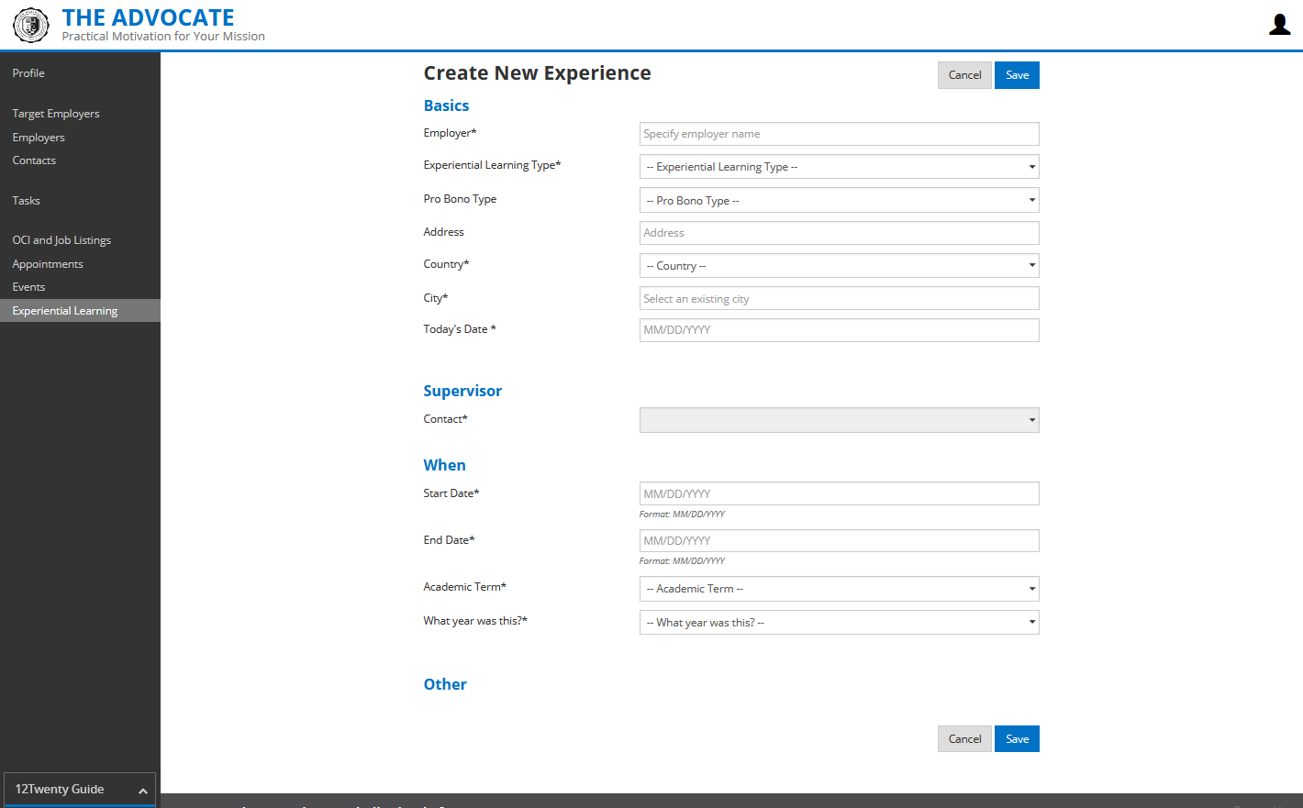

Under the Other section, you will need to click Yes for “Did you attend the Mandatory Externship Orientation Meeting? If not, DO NOT CONTINUE!” in order to complete the registration. Once you click Yes, you will be able to fill out/complete the remainder of the form and submit your registration for approval. When done, click Save.

**If you did not attend the Mandatory Externship Orientation Meeting or meet with Dean Ortega, you may not continue in the externship registration process**

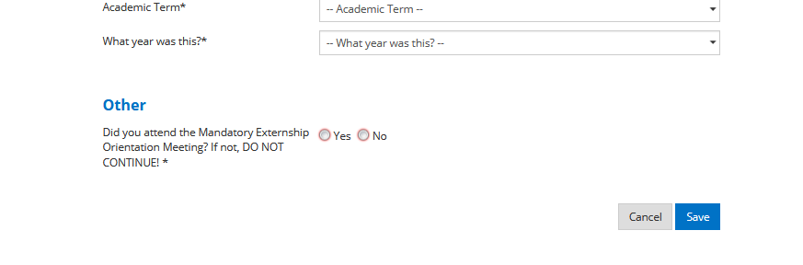

When you click Save, it will take you to a preview of your registration. This is the last time you can make any edits before you submit your registration for approval. If all the information is correct, click Submit for Approval at the top right. If not, click Action at the top right and select Edit or Delete.

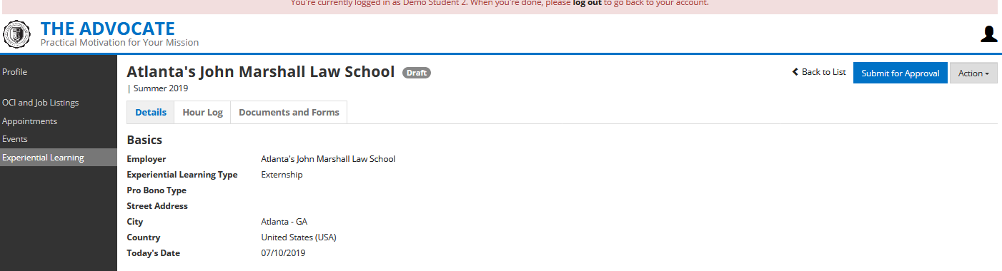

Once you click Submit for Approval, a box will appear asking you to confirm.

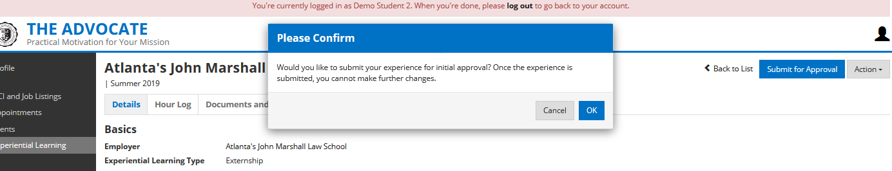

If you click Cancel, it will take you back to where you can make changes.

If you click OK, your registration will be submitted for approval and your status will be noted as Pending Initial Approval.

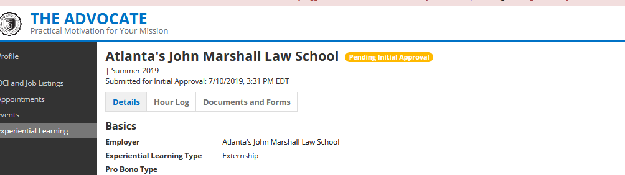

Externship Registration (Secured Placement Application) Approval Process
- 1st Approver- Bridgett Ortega/Paul Wilson
- 2nd- Externship Supervisor
- 3rd Approver- C. Ferebee

Once each Approver has approved the registration, your student status will be changed to In Progress

Add hours to your externship
- Once you have created your externship, you can add hours by clicking on the Hour Log tab
- Under the Hour Log tab, click Add Hours at the top right and a new window will appear called Create New Hour Log Entry
- Under Create New Hour Log Entry, enter the date, hours, and the description of your service
- Once complete, click Save and the hours will be added to your externship
**12Twenty tracks hours by day. If you wish to enter your hours by the week, please enter the last day the hours completed and then enter the week start date and end date in the description box along with the work performed.**

Evaluations (Student, Employer)

Student
- Log in to your account
- Go to Experiential Learning, select your externship
- Click the Documents and Forms tab
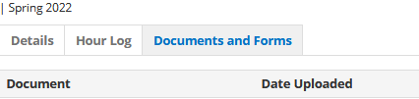
- Find the appropriate student evaluation and click the ellipsis to the right
  - Student Self Evaluation (midterm)
  - Student Program Evaluation (end of the semester)
- Click Complete Form
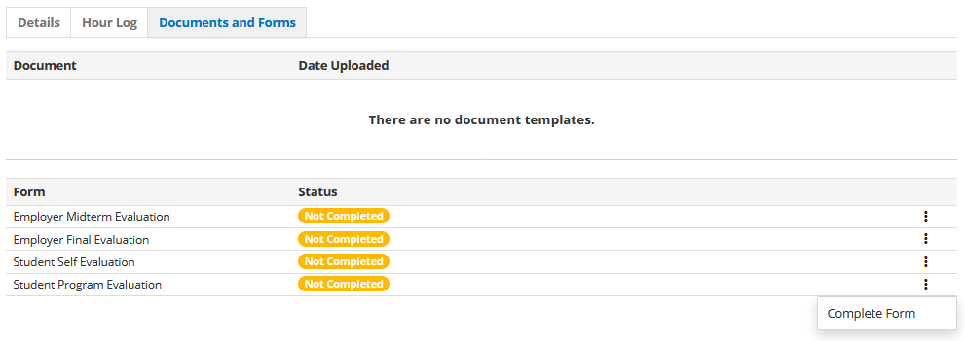
- Once you click Complete Form, fill out all of the required fields and click Save when done
- When you click Save, the status of your selected evaluation will be changed to Completed

Employer
Employer evaluation links will be sent out by the Office of Experiential Learning. Once this occurs, students are more than welcome to share the employer evaluation link with their supervisor by selecting the appropriate evaluation, clicking on the ellipsis to the right, and then clicking Share. Once you click Share, a window will appear asking if you want to share the form with the supervisor at the specified email address. If information is correct, click Send. When you click Send, an automated email will be sent to your supervisor with a link to your evaluation.

Completion
Upon completion of your externship (all requirements must be met)
- Log in to your account
- Go to your Experiential Learning, select your externship and click Submit. This will change your externship status to Complete

Tips
- The next to each question will provide additional information for that question

Troubleshoot
Please use the help tool (12Twenty Guide) located in the menu on the left at the bottom for assistance with basic profile information, applying to jobs, documents, etc.* If additional assistance is required or you encounter an issue not covered, please submit a ticket to:

