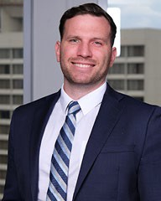 | Georgia Bar Success Award  Nathan Azarowicz  J.D. Candidate 2024  “I am deeply grateful for the Georgia Bar Success Endowed Award. This Award will have a major impact in assisting me in my final semester of law school and in my preparation for the Georgia Bar. I would like to thank Dr. Markovitz and Atlanta's John Marshall Law school for this award. I will be able to use this award better prepare for the Bar and alleviate much of the stress felt in the bar application process.”
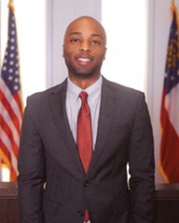 | Georgia Bar Success Award  Joshua Redmond  J.D. Candidate 2024  “Dear Dr. Michael Markovitz and the Scholarship Committee,  I extend my heartfelt gratitude for selecting me as the recipient of the Georgia Bar Success Endowed Award. This generous scholarship significantly alleviates the financial burden associated with the Bar exam, allowing me to pursue my passion for law with dedication and focus. I am truly honored to have been chosen and am motivated to excel in my legal career, contributing meaningfully to the field. Thank you once again for this invaluable opportunity.”
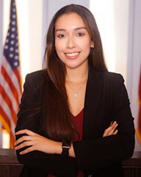 | Georgia Bar Success Award  Maria P Velasco  J.D. Candidate 2024  “I am sincerely grateful for the Georgia Bar Success Award. This recognition means a lot to me, and I appreciate the support from the legal community. It inspires me to continue my dedication to the field.”

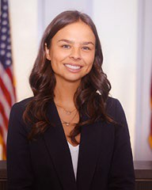 | John E. Ryan Scholarship  Madeline Deye  J.D. Candidate 2025  “I appreciate the generosity of this scholarship, it will make a huge financial impact for me. Thank you for your decision to move forward with me as the recipient, I am honored to receive this award.”
 | Merchant & Gould Scholarship  Jordan Robinson  J.D. Candidate 2024  “Words cannot express my gratitude in receiving the Merchant & Gould Scholarship. To know that my journey and hardwork received the attention of this firm is heartwarming. This scholarship will definitely help ease financial difficulties associated with bar expenses as well as law school attendance and help me on my journey to becoming an Attorney. I'd like to give thanks to Wendy Aina for working as hard as she does to make these opportunities available to us law students and I would again like to thank Merchant and Gould for making the scholarship available.”
 | Merchant & Gould Scholarship  Alexis Burnett  J.D. Candidate 2024  “Receiving the Merchant & Gould Scholarship is a profound honor as I embark on my final semester of law school. This scholarship will help alleviate some of the financial challenges as I complete my legal education, and I am deeply grateful for this valuable assistance. My aspiration is to one day be in a position to pay it forward, creating opportunities for future law students and paving the way for their success. I am committed to using my influence to diversify the field of Intellectual Property law and contribute to a more inclusive and innovative legal landscape.”

 | Gorinshteyn & Watkins LLC Law Journal Fellowship  Jacob Belcastro  J.D. Candidate 2024 “To Attorney Watkins,  I am deeply honored to be the recipient of the Gorinshteyn & Watkins LLC Law Journal Fellowship. This fellowship will not only aid me drastically in covering the costs for tuition and textbooks, but will also help the Law Journal in covering various expenses throughout the year. Specifically, much of this funding will be designated towards the annual Symposium to assure a venue, amenities, and payment for alumni CLE credit fulfillment.  The impact of this funding is more than can be put into words, and on behalf of both  myself as well as the Atlanta's John Marshall Law Journal- thank you very much.”
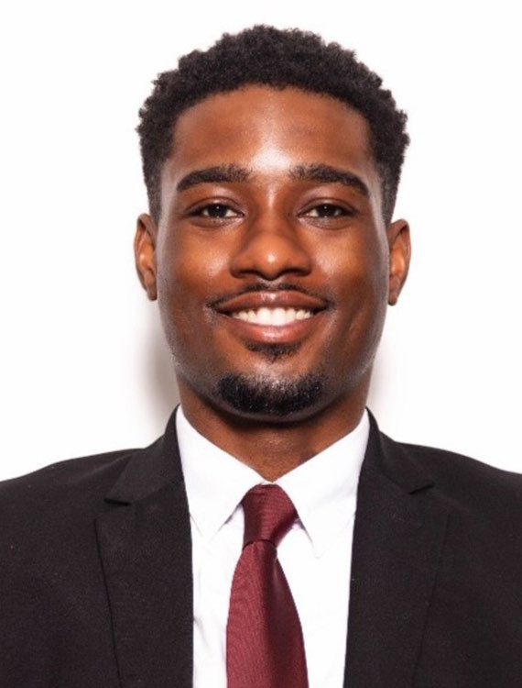 | Melissa Hamrick Scholarship  Devin Eady  J.D. Candidate 2025  “Thank you so much for this generous award. I am currently an evening student who works several jobs during the day to make ends meet and this is a huge weight off my shoulders in light of rising transportation costs. I genuinely appreciate your generosity and your help with my academic career.”

